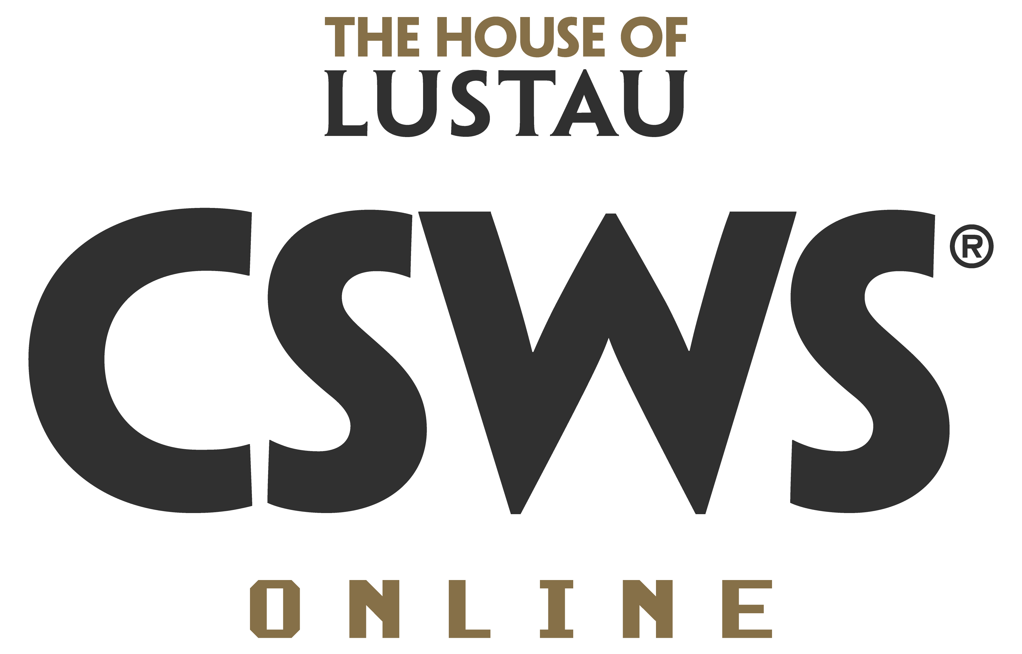
Full name:
CSWS Online Course Date:

The importance of education for the sherry wine industry
Distinguishing between education for professionals and education for consumers, how much do you need to change your game? Providing more technical versus “emotional” content? Is promoting trips to the region and winery visits still a key part of the educational process? Is one of the biggest challenges how to teach sherry in just a few minutes, perhaps using a new approach and/or classification? How should we fight the stigmas around sherry and the association of these wines with very specific demographics or even stereotypes?

-

(Insert your text and/ or images here)

In compliance with the current EU standards for PROTECTING PRIVACY AND PERSONAL DATA, we are hereby advising that your personal and intellectual data related to this competition will be managed by Emilio Lustau S.A. for administrative or marketing purposes while executing this education program, and that when marking the option below you accept receiving commercial information from us for an indefinite period of time. Your personal data will not be disclosed with other third parties. The legitimate basis of this agreement is the contractual relationship between the parties, for the service provided and the consent of the user. We hereby inform that you are able to exercise your rights to access, rectify, suppress, oppose, limit the use, transfer and opt out of automatic generated messages by sending a signed request by electronic mail addressed to protecciondatos@caballero.es , forwarded from the email address you originally submitted when registering. For your knowledge, our Data Protection Officer’s contact is ejercicioderechos@grupodatcon.com. If at any time you deem that your rights have been infringed, you have the right to file a complaint with the Agencia Española de Protección de Datos (www.agpd.es)

☐ Please click on the checkbox to accept the data policy and if you accept receiving commercial information from us.

